Adding of Passwords to a Newly Created Password List

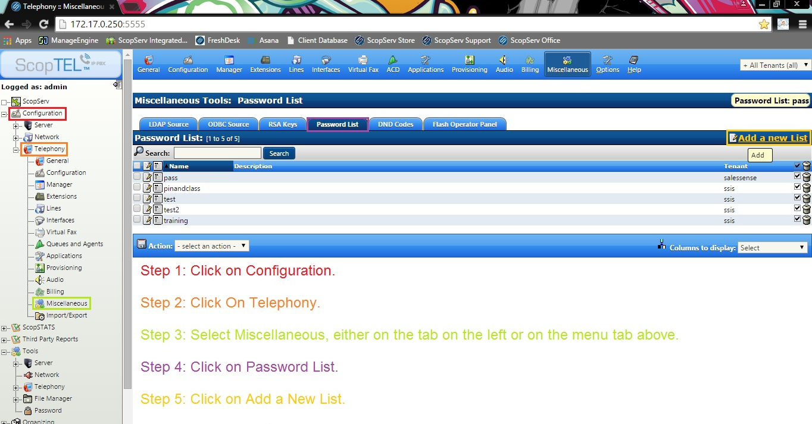

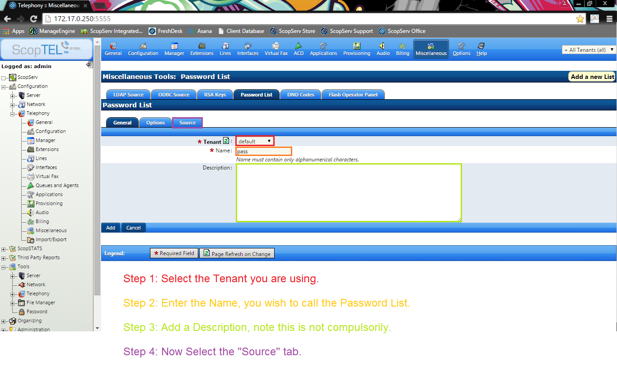
Configuring Newly Created Password List

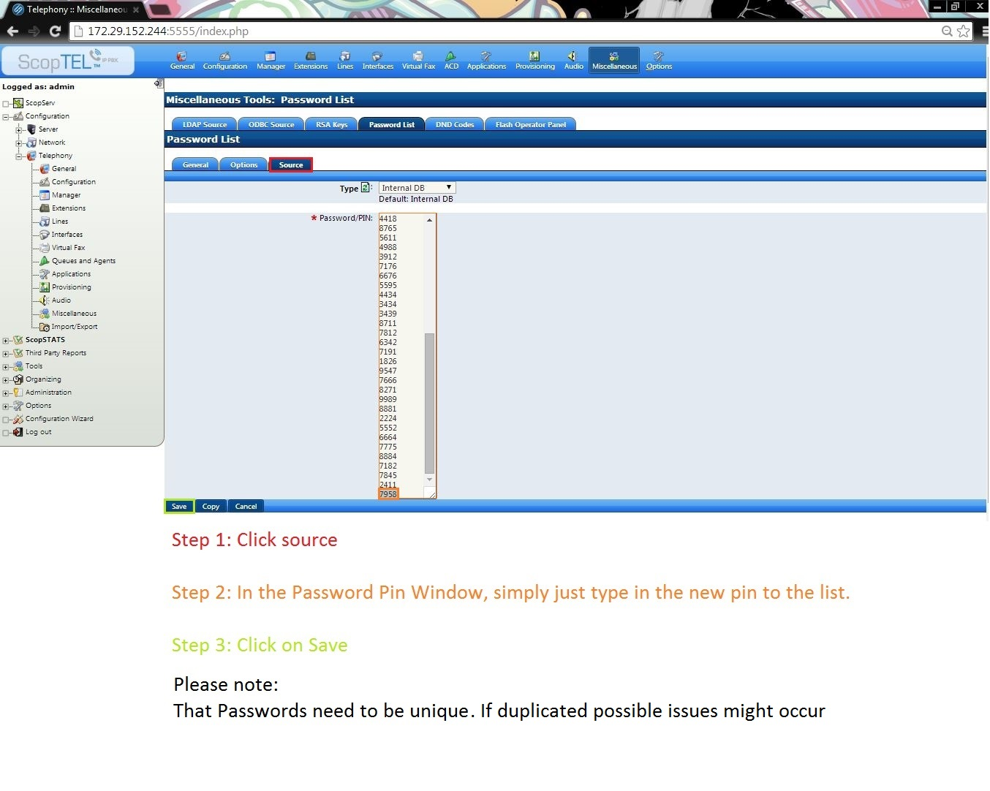

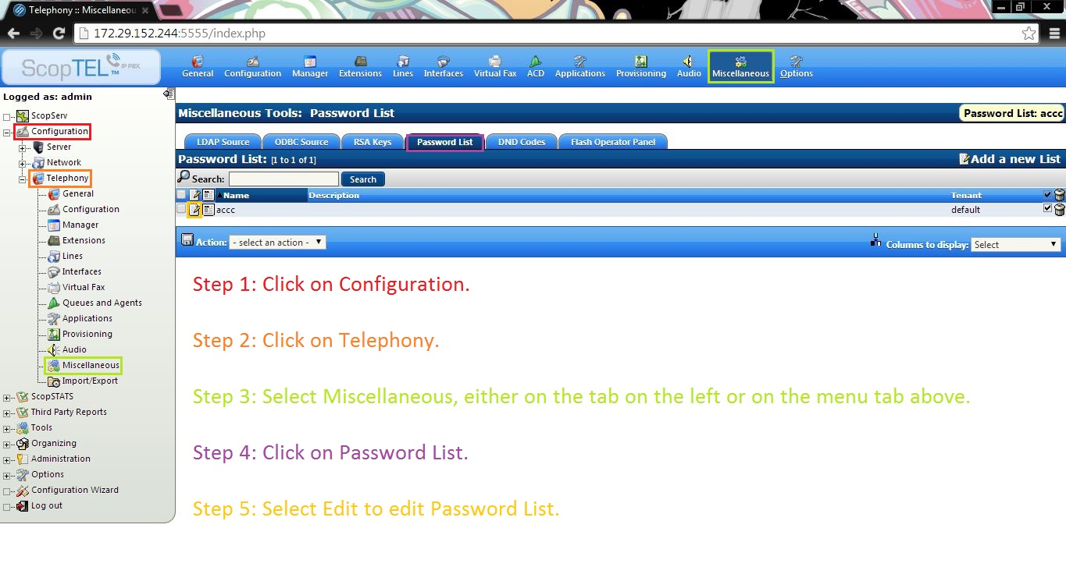
Adding of Passwords to an existing Password List

Password List Edit Tab

End Process
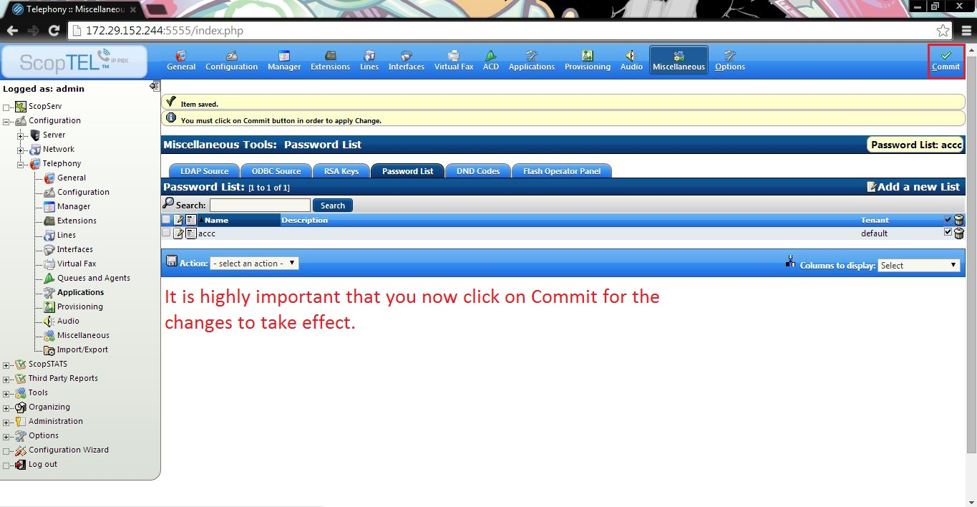

If you have any further questions or issues, please don’t hesitate to give us a call

